Problem 1
Read in a number and print it out.
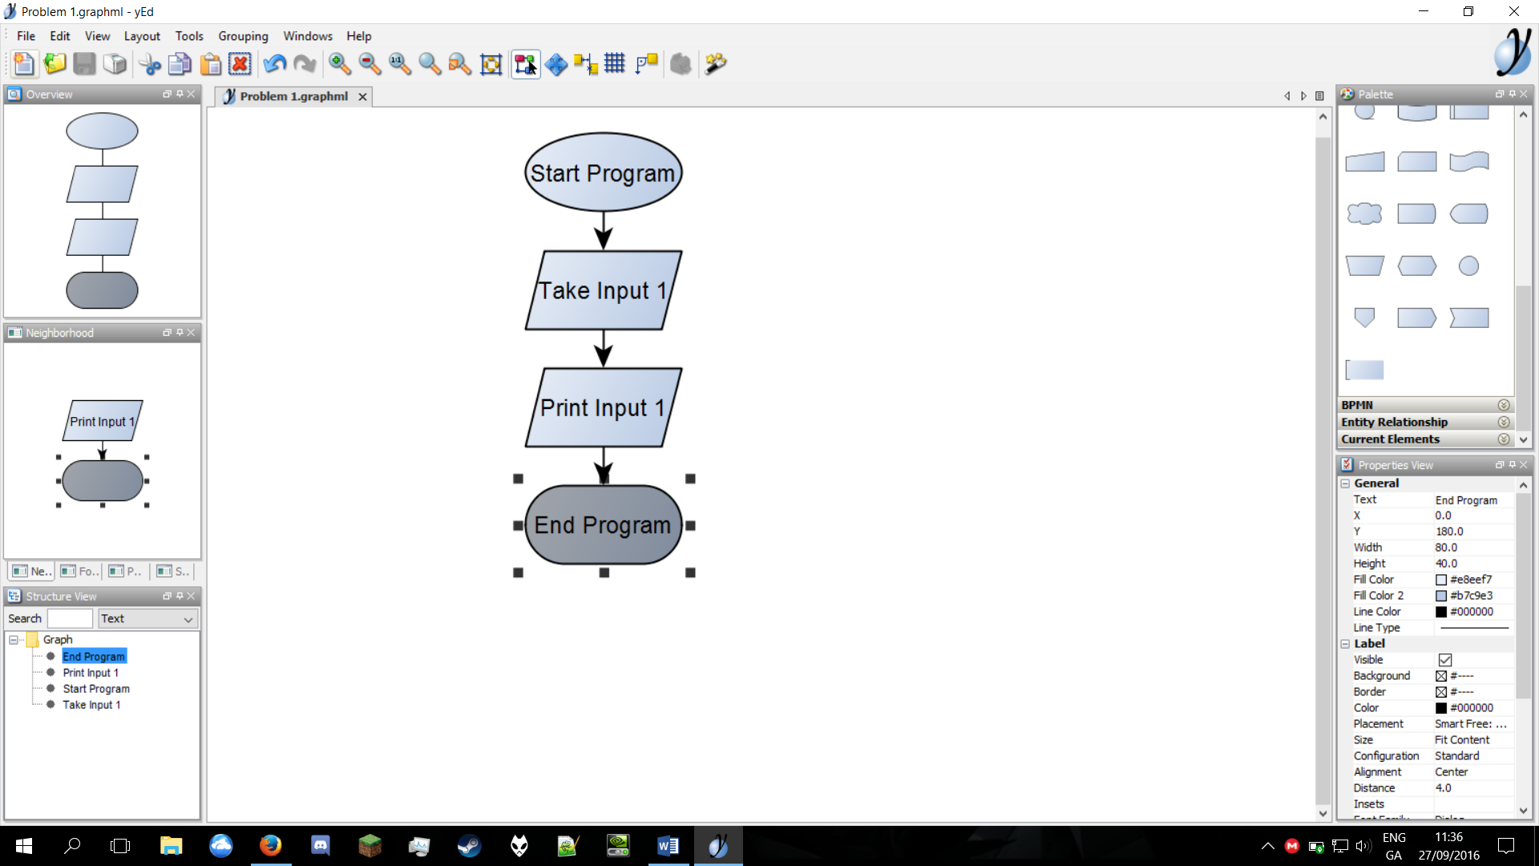

Problem 2
Read
in a number and print
out
double the
number.
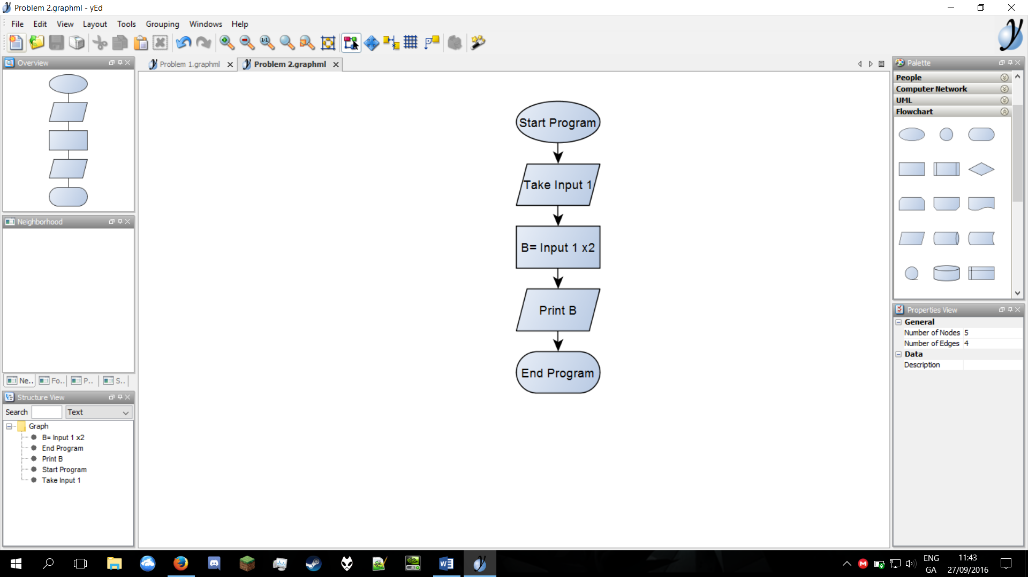

Problem 3
Read
in a number, check if it is odd or even.
